**Assignment 1**

**PART 3 - PROGRAMMING ASSIGNMENT**Create a database for a Contact Management System in MongoDB.  
You could use any attributes you like, first name, last name, phone, address, zip, etc.  
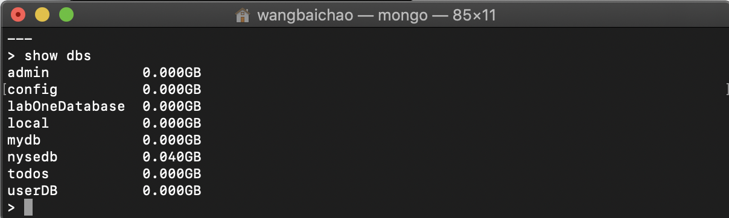

New a var called contact1 to save first contact info

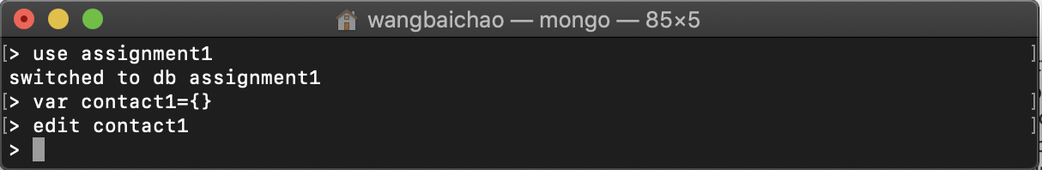

Edit with vim

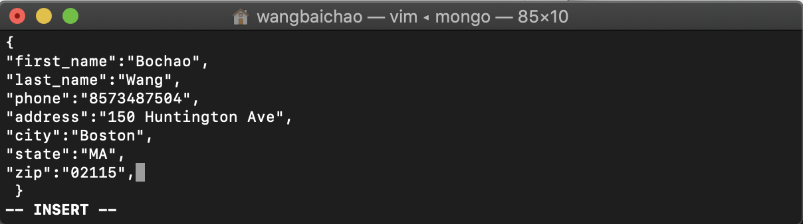

Insert first one and create collection

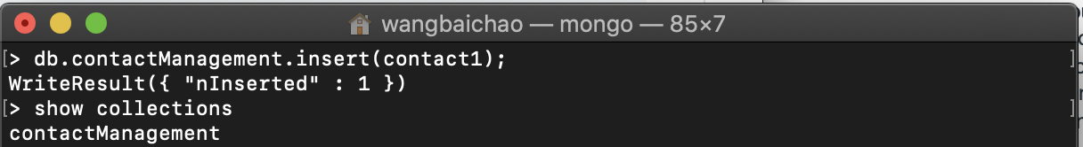

Then find it out

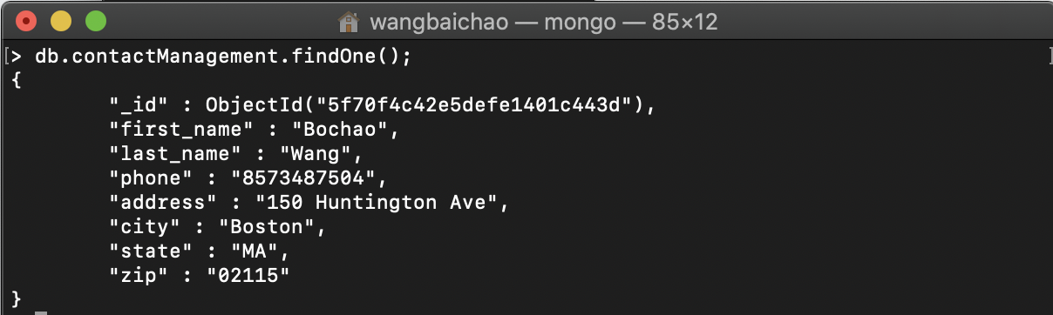

Create 5 records with different attributes and values you choose.

Create 5 vars

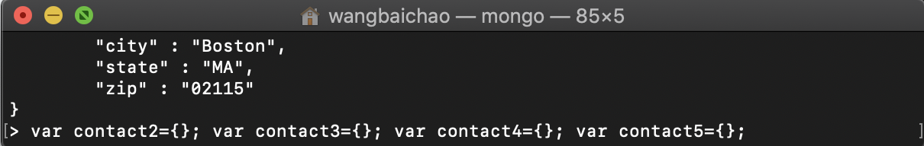

Edit them

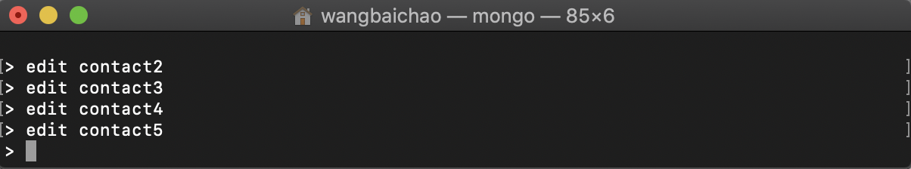

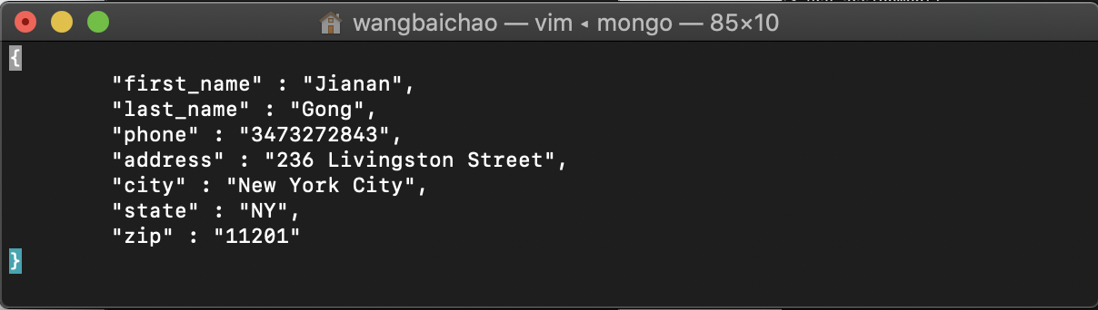

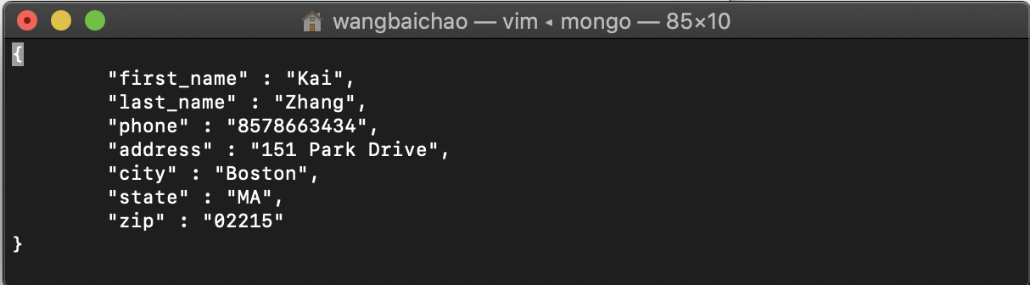

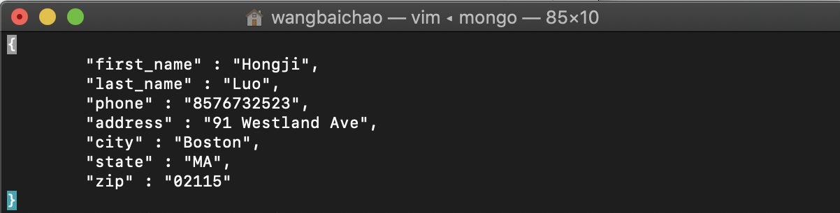

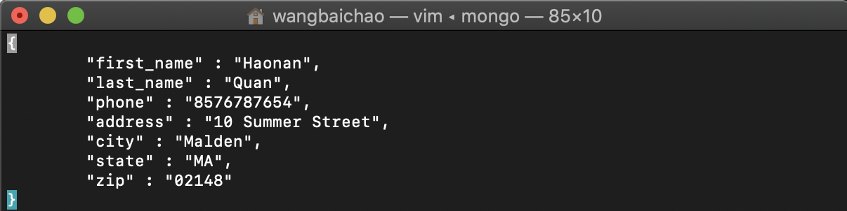

User insertMany to insert 5 contacts

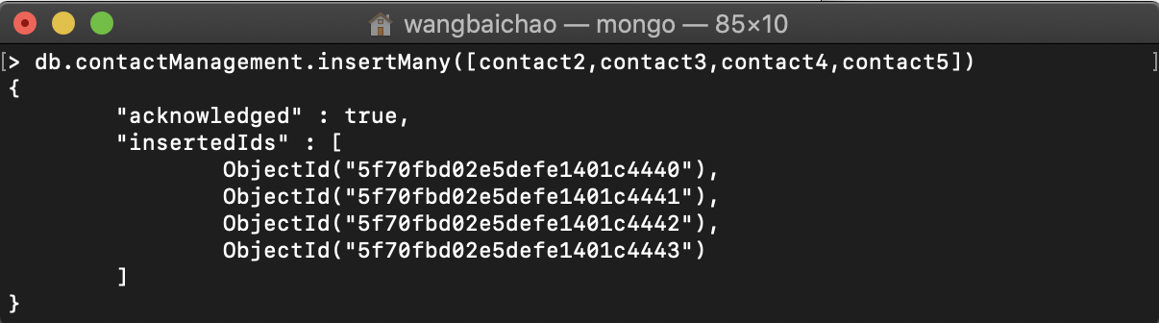

Find them out

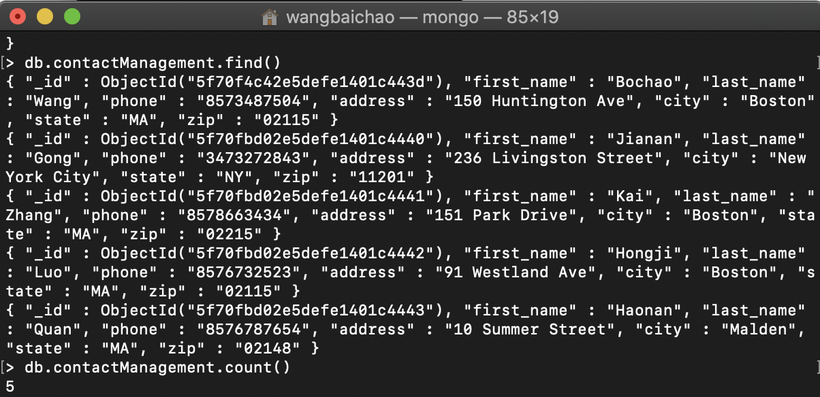

Then delete any one record of your choice.  
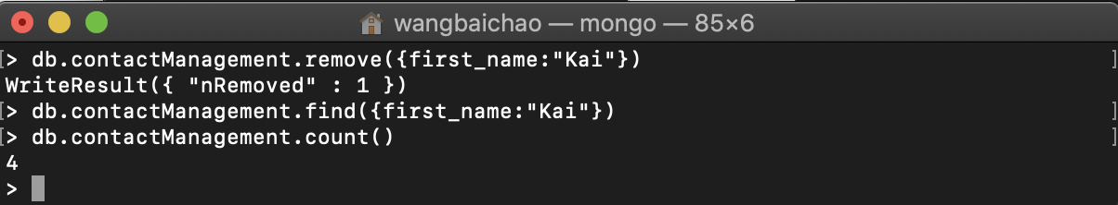

Then update some information from any one of the records of your choice.  
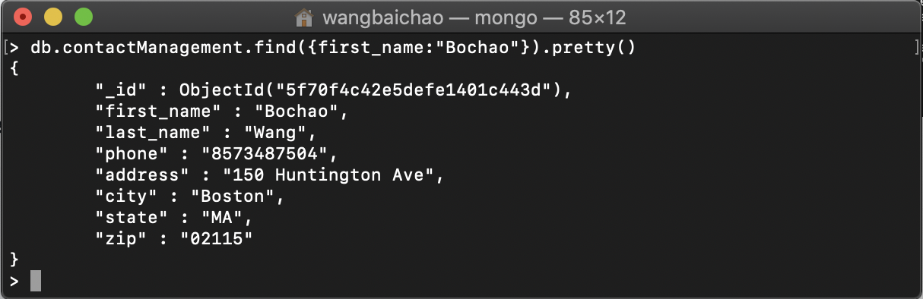

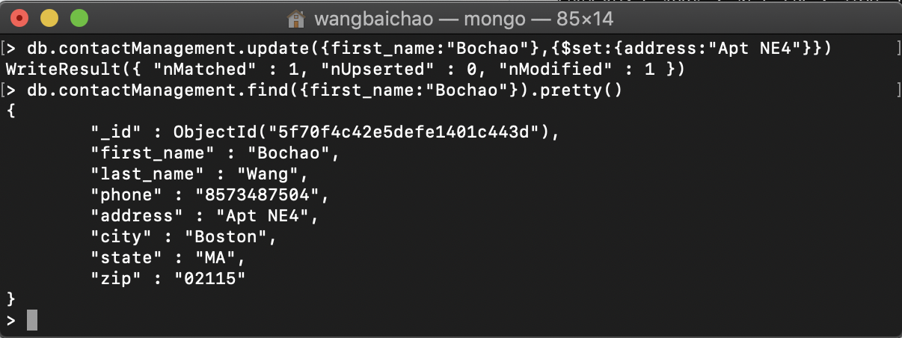

**PART 4 - PROGRAMMING ASSIGNMENT**Create a collection called ‘games’. We’re going to put some games in it.  
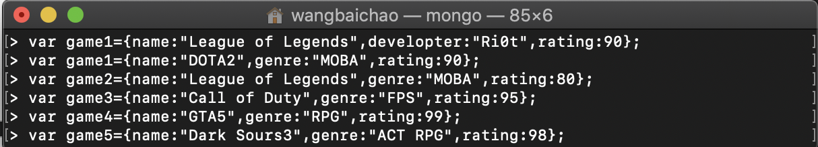

Add 5 games to the database.  
Give each document the following properties: name, genre, rating (out of 100)  
If you make some mistakes and want to clean it out, use remove() on your collection.

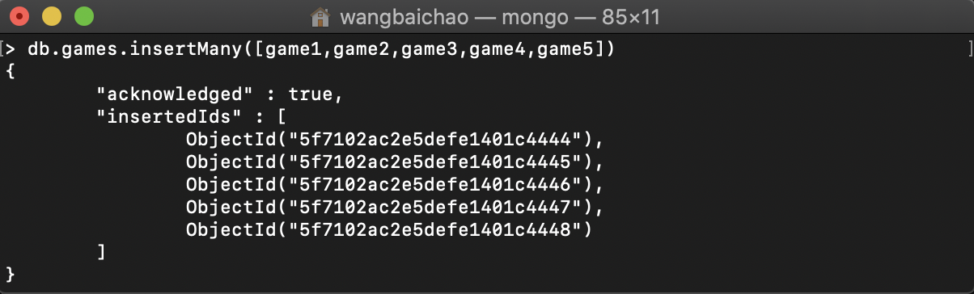

Write a query that returns all the games.

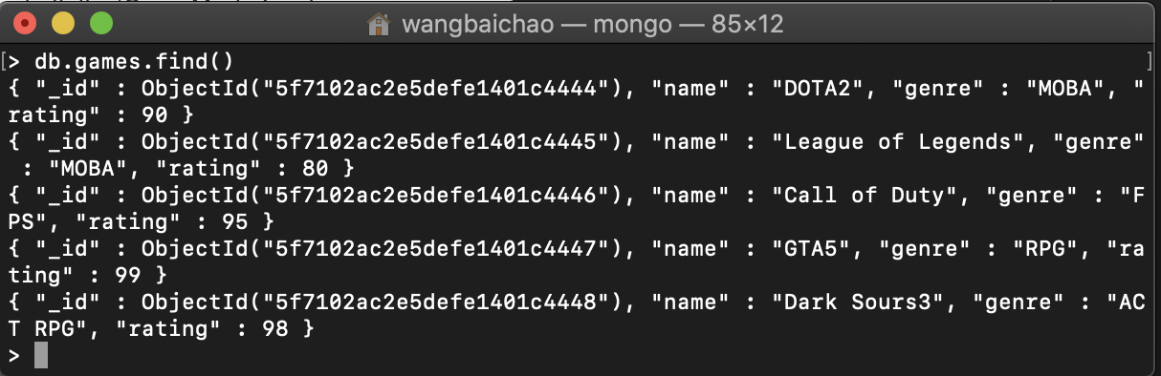

Write a query to find one of your games by name without using limit().

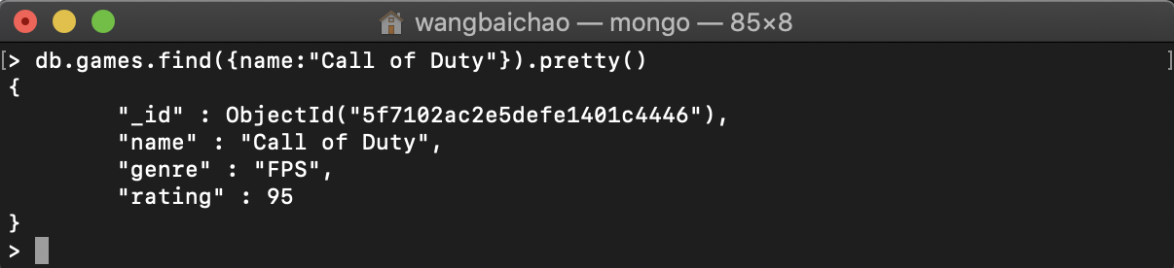

Use the findOne method.  
Look how much nicer it’s formatted!  
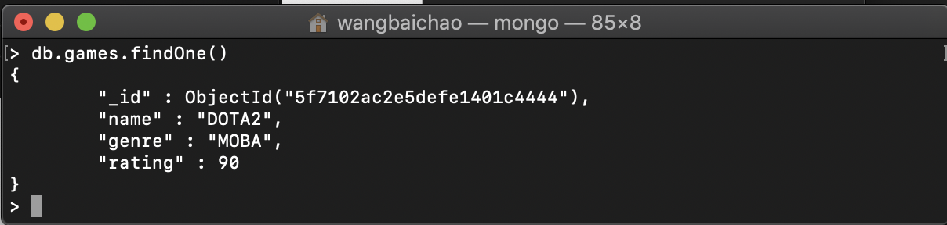

Write a query that returns the 3 highest rated games.

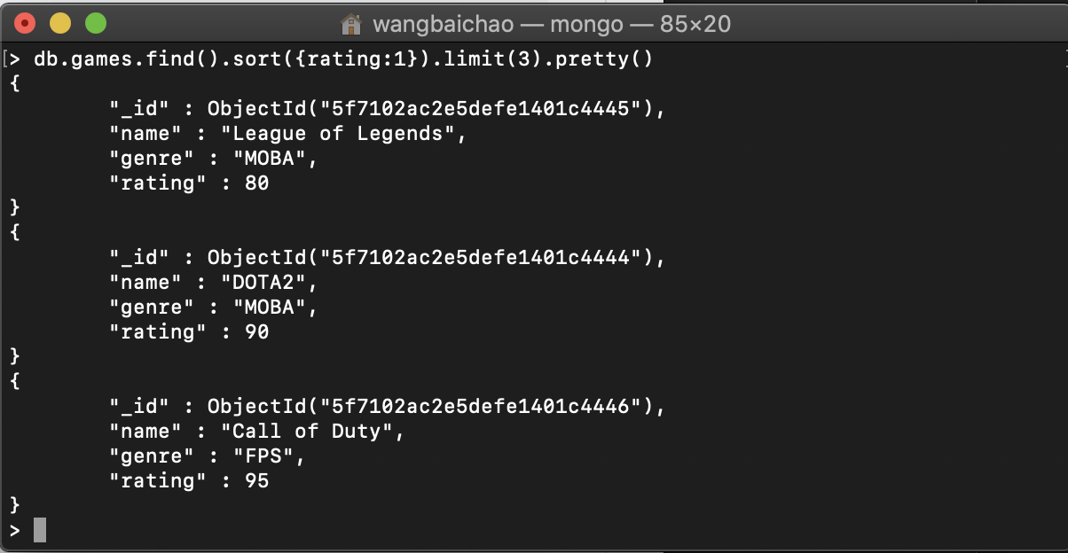

Update your two favorite games to have two achievements called ‘Game Master’ and ‘Speed Demon’, each under a single key.  
Show two ways to do this.  
Do the first using update() and do the second using save().  
Hint: for save, you might want to query the object and store it in a variable first.

Use set  
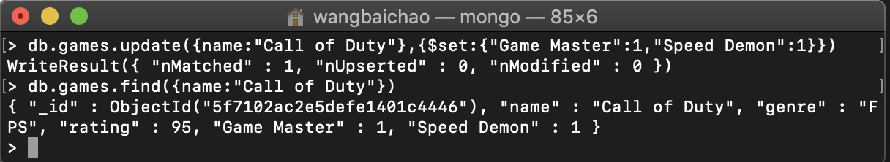

Use save

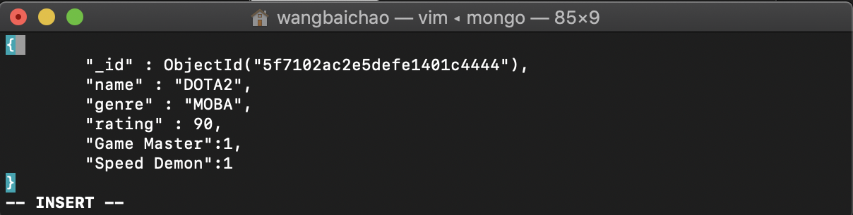

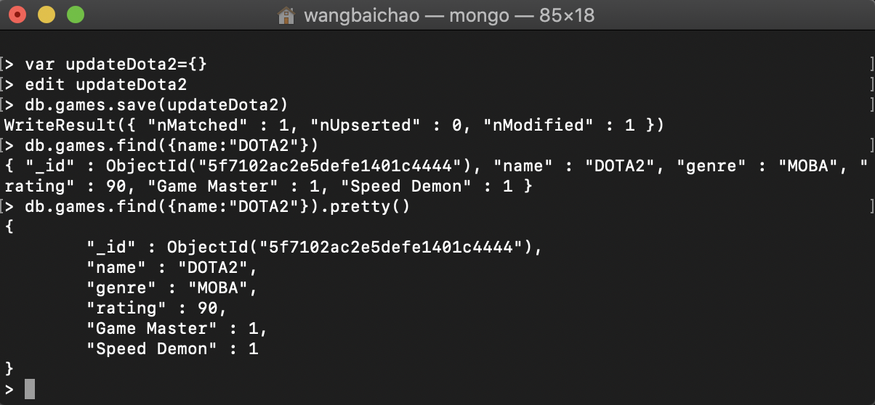

Write a query that returns all the games that have both the ‘Game Master’ and the ‘Speed Demon’ achievements.

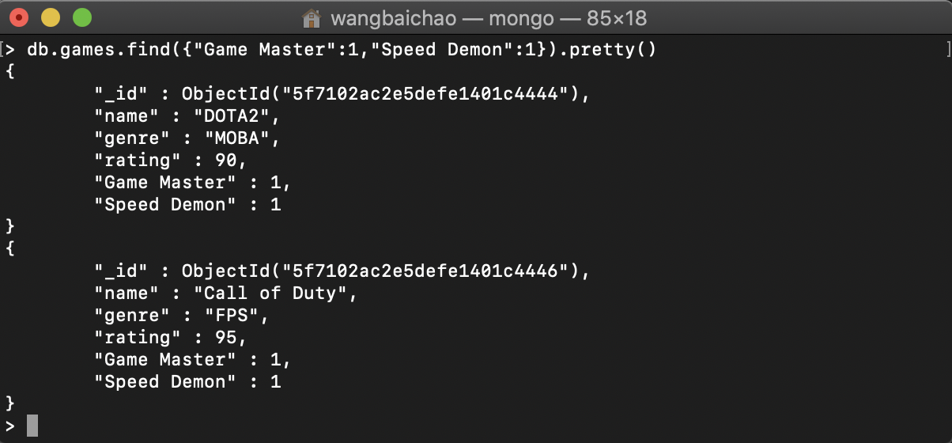

Write a query that returns only games that have achievements.  
Not all of your games should have achievements, obviously.

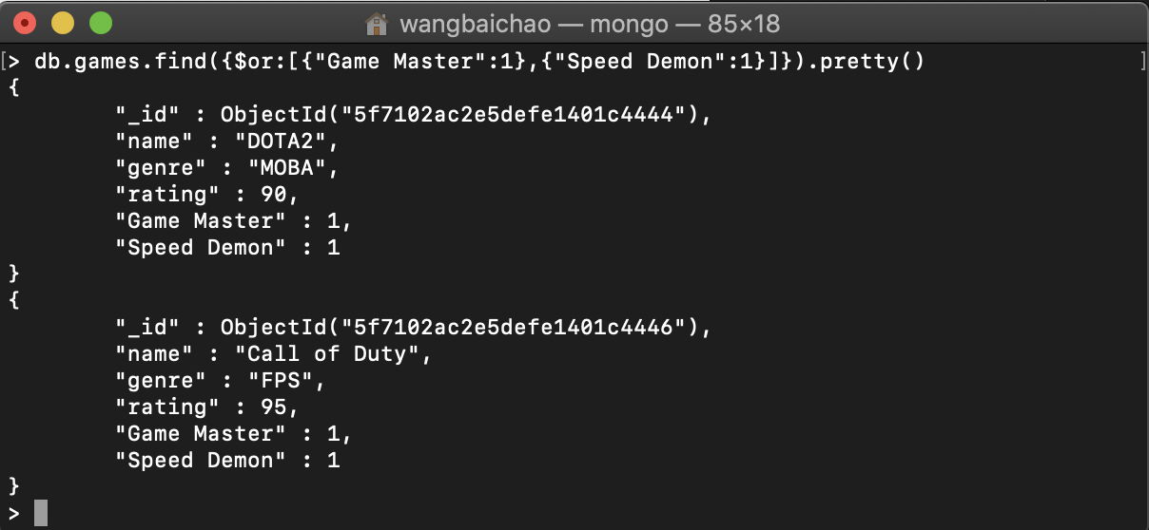

**PART 5 - PROGRAMMING ASSIGNMENT**Execute 5 commands of your choice from each of the following groups, and paste the screenshots in a word document.  
mongo> help             [5 commands]

1. show dbs --show database names

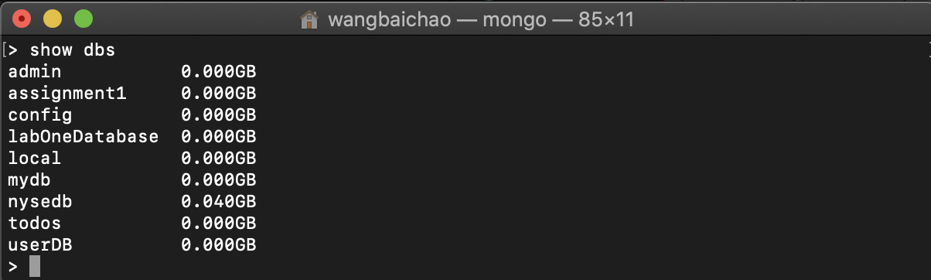

1. show collections --show collections in current database

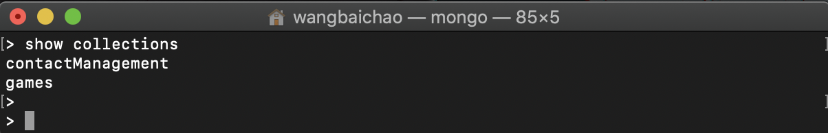

1. show log [name]--prints out the last segment of log in memory, 'global' is default

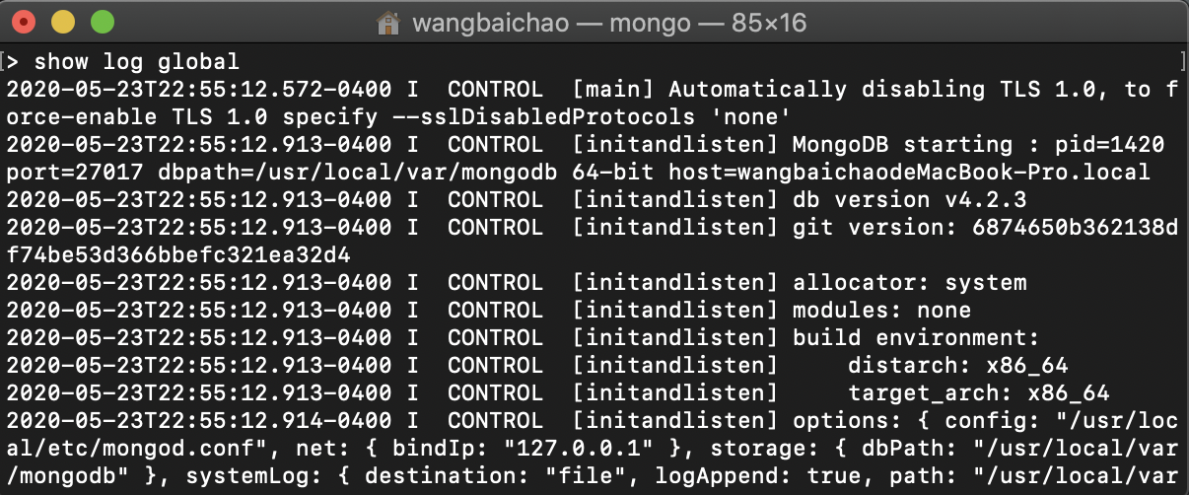

1. use <db_name> --set current database

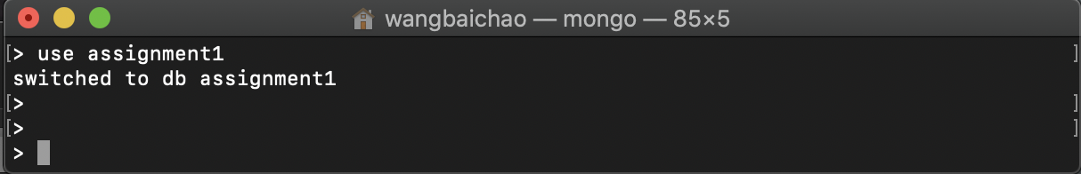

1. show profile --show most recent system.profile entries with time >= 1ms

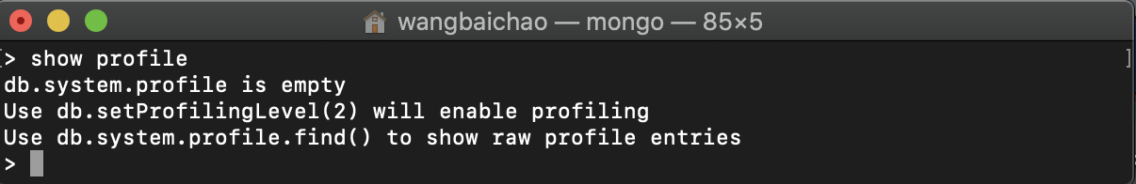

mongo> db.help()        [5 commands]

1. db.getName()

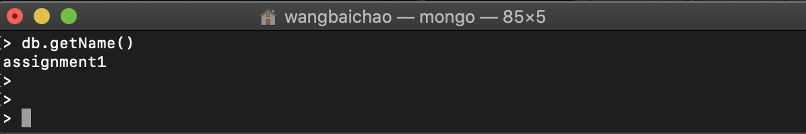

1. db.hostInfo() --get details about the server's host

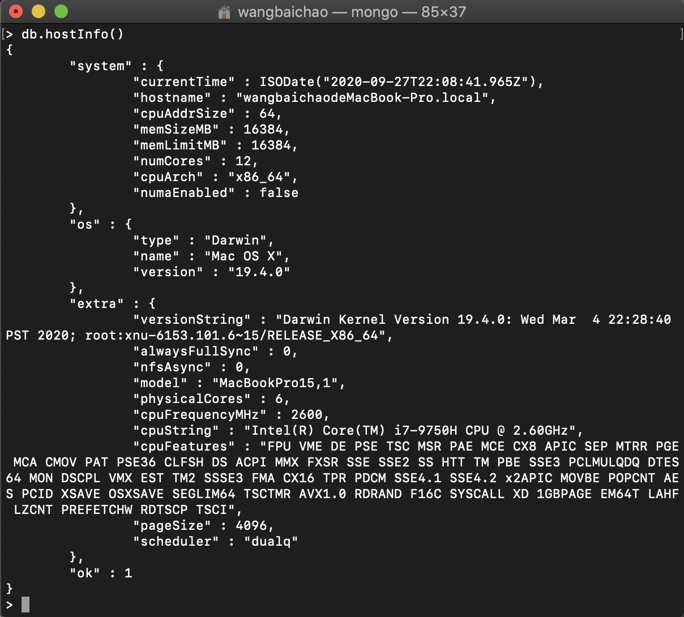

1. db.getMongo() --get the server connection object

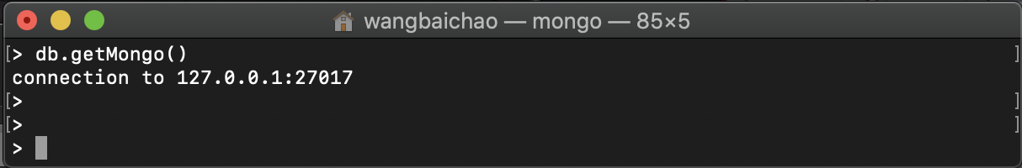

1. db.version() --current version of the server

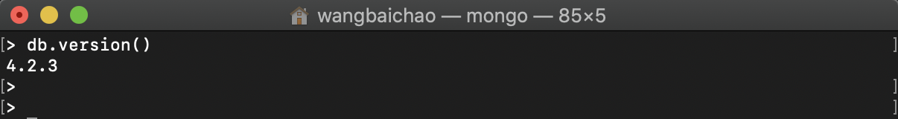

1. db.stats() –-print statement of database

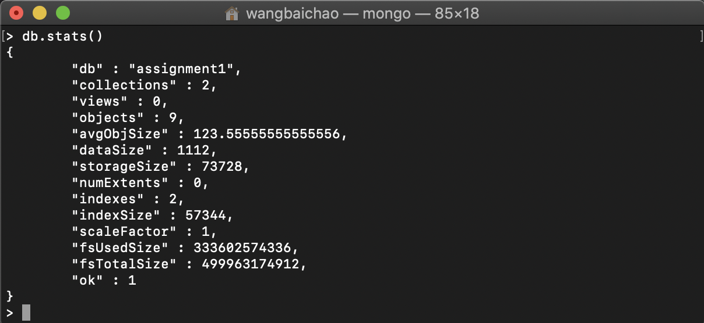

mongo> db.mycoll.help() [10 commands]

1. db.mycoll.find(...).limit(n)

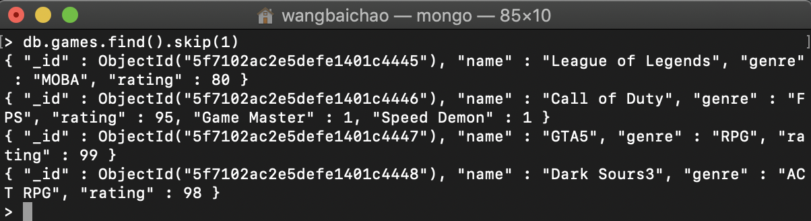

1. db.mycoll.distinct( key, query, <optional params> ) - e.g. db.mycoll.distinct( 'x' ), optional parameters are: maxTimeMS

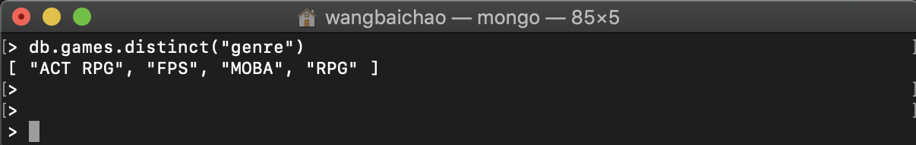

1. db.mycoll.countDocuments( query = {}, <optional params> ) - count the number of documents that matches the query, optional parameters are: limit, skip, hint, maxTimeMS

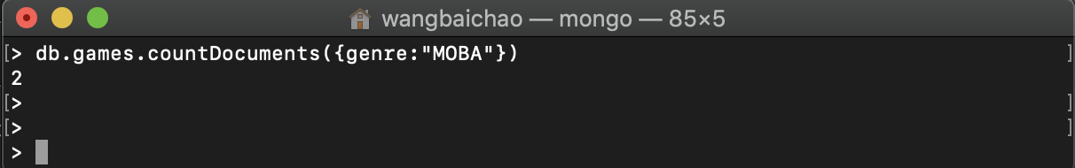

1. db.mycoll.aggregate( [pipeline], <optional params> ) - performs an aggregation on a collection; returns a cursor

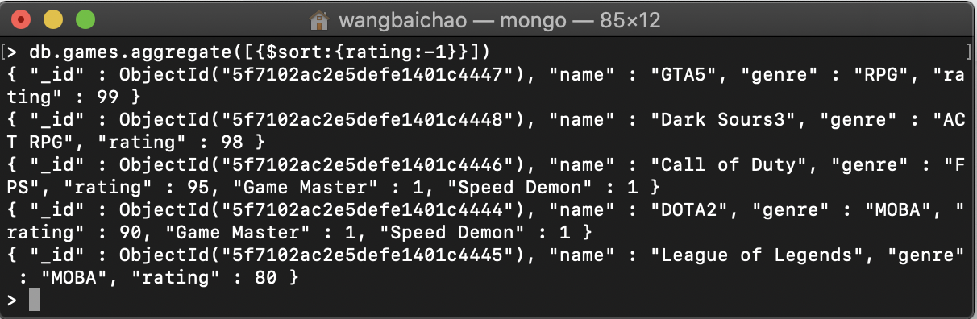

1. db.mycoll.totalSize() - storage allocated for all data and indexes

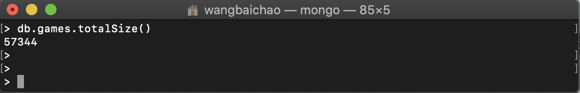

1. db.mycoll.renameCollection( newName , <dropTarget> ) renames the collection.

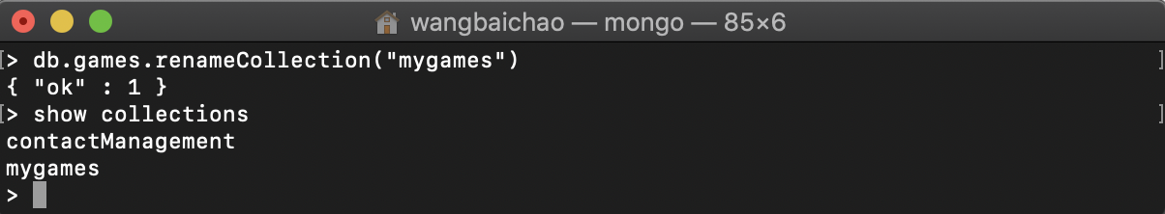

1. db.mycoll.findOneAndUpdate( filter, <update object or pipeline>, <optional params> ) - update first matching document, optional parameters are: projection, sort, maxTimeMS, upsert, returnNewDocument

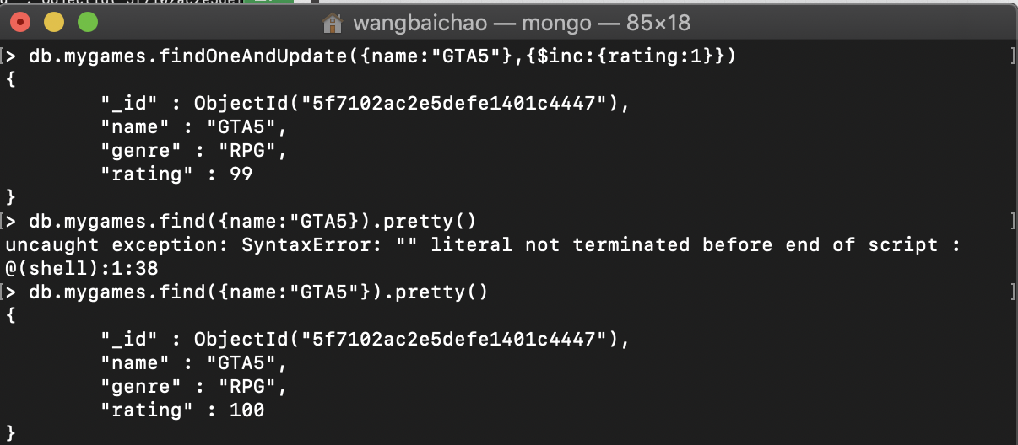

1. db.myColl.latencyStats() - display operation latency histograms for this collection

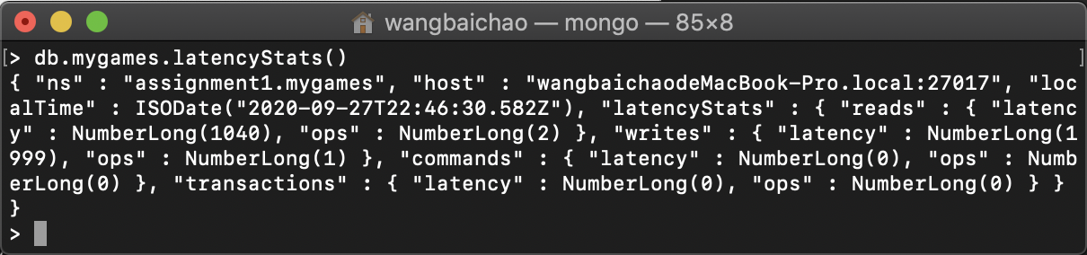

1. db.myColl.dataSize()

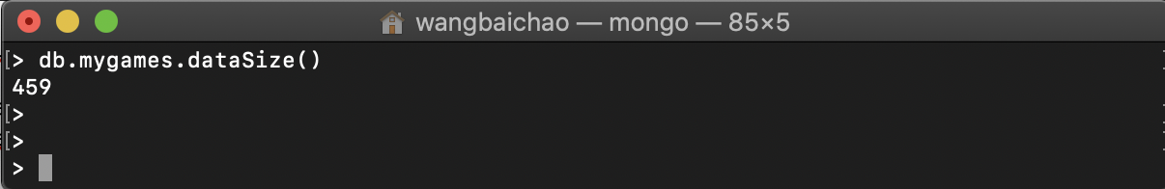

1. db.myColl.count( query = {}, <optional params> ) - count the number of documents that matches the query, optional parameters are: limit, skip, hint, maxTimeMS

